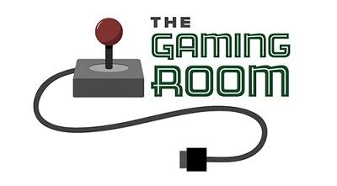

Draw it or lose it

CS 230 Project Software Design Template
Version 1.0

Table of Contents

CS 230 Project Software Design Template 1
Table of Contents 2
Document Revision History 2
Executive Summary 3
Requirements 3
Design Constraints 3
System Architecture View 3
Domain Model 3
Evaluation 4
Recommendations 5

Document Revision History

Version | Date | Author | Comments
1.0 | 01/23/2026 | Cristian Gallegos | Updated summary, requirements, constraints and domain model.
2.0 | 2/7/2026 | Cristian Gallegos | Security Features
3.0 | 2/21/2025 | Cristian Gallegos | Recommendations

Instructions
Fill in all bracketed information on page one (the cover page), in the Document Revision History table, and below each header. Under each header, remove the bracketed prompt and write your own paragraph response covering the indicated information.

Executive Summary

The Gaming Room has tasked us with porting their app-based game Draw It or Lose it to a web based game that severs multiple platforms. Our client wants the following software requirements for their port, they want the game to have the ability to have more than one team be involved, with each team having the ability to have multiple players assigned to them. The client also wants the game and team to have unique names and for our software to check if a name has been used. They have requested that only one game can exist in memory at any given time, so we have to create unique identifiers for each game, team, and player.

Requirements

- Create a web-based version of their gaming app
- When in a game
  - Can create multiple teams
    - Within the teams, be able to add multiple players
  - Game and team must have unique names
    - Checks to see if name is in use
  - Only one instance of game can exist at one time
    - Unique identifiers for game, team, player

Design Constraints

- Game has to work on multiple web browsers based on app store version. Change the user interface to match web-based browsers on multiple devices but at the same time match the app design.
- Unique names for game and teams. To ensure no naming conflicts encountered we must check to see if the name has been used
- One iteration of the game can exist. To ensure game is functional only one instance of the game can run in memory

System Architecture View

Please note: There is nothing required here for these projects, but this section serves as a reminder that describing the system and subsystem architecture present in the application, including physical components or tiers, may be required for other projects. A logical topology of the communication and storage aspects is also necessary to understand the overall architecture and should be provided.

Domain Model

From the UML model bellow we can see that the following classes game, team, player are subclasses to the entity class, meaning they all inherit properties from the entity class which includes variables like id and name. The GameService class is associated to the game class were it can have an association of zero to many, the game class is associated to the team class were the association can be zero to many, and finally the team class is associated to the player class where the association is once again zero to many. The programDriver class is pointing to the Singleton tester, this allows the program driver to test if one game can exist in memory.
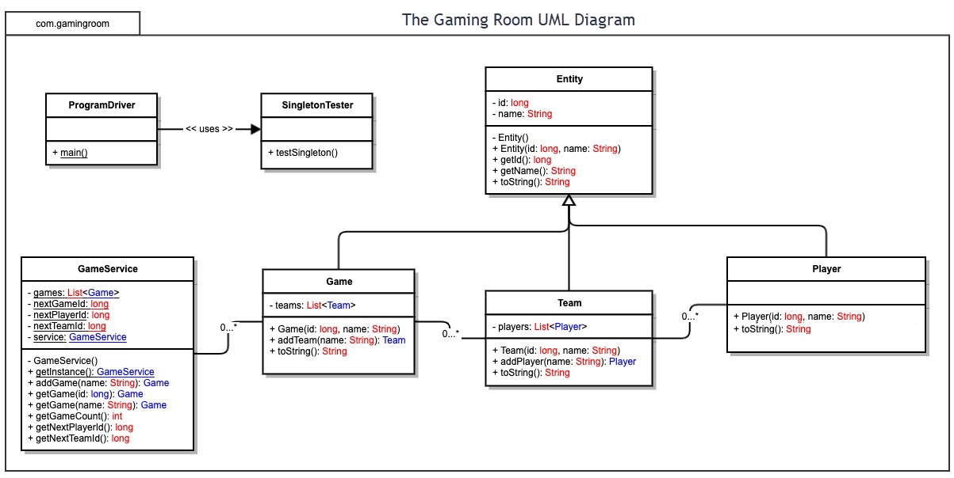

Evaluation

Using your experience to evaluate the characteristics, advantages, and weaknesses of each operating platform (Linux, Mac, and Windows) as well as mobile devices, consider the requirements outlined below and articulate your findings for each. As you complete the table, keep in mind your client’s requirements and look at the situation holistically, as it all has to work together.

In each cell, remove the bracketed prompt and write your own paragraph response covering the indicated information.

Development Requirements | Mac | Linux | Windows | Mobile Devices
Server Side | Advantages - Mac has Unix based OS, known for its strong security features. Mac OS combines open-source technologies with apple’s industry leading manageability and ease of use  Weakness – common industry software and tool are not compatible. Not the best choice for large scale server deployment | Characteristics- Open source, source code is open to the public. More secure with less downtime.  Advantages- since its open source the cost is free to use, with it being open source there is a community support for Linux.  Disadvantages- Can be complex to new users. Some software is not compatible with Linux. | Characteristics- User friendly interface even for new users, compatible with .NET and other Microsoft technologies, Microsoft support  Advantages- integrates well with other Microsoft products, highly scalable servers, security is often updated by Microsoft.  Disadvantages- Servers are often more expensive than Linux. They also require more resources than other servers such as CPU and memory | Characteristics- Portable anywhere there is internet connection, smaller design so less power, memory, storage  Advantages- Users can use it anywhere, large userbase  Disadvantages- if user losses connection with their network they lose connection to server, power and memory can affect final product
Client Side | Cost- Mac tends to be more expensive both on the software and hardware side.  Time- On multiple platforms development time could increase.  Expertise- Mac needs an developer familiar with their hardware and software since they tend to program in swift and objective-C | Cost- since Linux is open source the software can be lower. Special training could cost more.  Time- users might need more time to learn Linux  Expertise- Developers need to be well versed in how Linux works | Cost-Multiple types = greater cost for testing and developing for each client  Time and expertise also have the same problems. | Cost-Multiple types = greater cost for testing and developing for each client  Time and expertise also have the same problems.
Development Tools | Programing languages- mac uses swift and objective-c.  IDE’s and tools- Xcode, AppCode. | Programming languages- Python, JavaScript, C++  IDE’s- Eclipse, NetBeans, Git | Programming Languages- C#, JavaScript, HTML/CSS  IDE’s -Visual Studio, .NET Framework, SQL Server | Programming Languages-  Android: Java, Kotlin  iOS: Swift, Objective-C  Cross-platform: JavaScript, Dart  IDE’s-  Android: Android studio  iOS: Xcode  Cross-platform: Visual Studio, IntelliJ, IDEA  Other tool: Unity, unreal Engine

Recommendations

Analyze the characteristics of and techniques specific to various systems architectures and make a recommendation to The Gaming Room. Specifically, address the following:

- Operating Platform: The operating system that we would recommend is windows because it’s user friendly and beginner friendly

- Operating Systems Architectures: The windows os uses GUI instead of a CLI interface making it easier for the user, meaning that from the development side it easier for the developer to interact with the os due to having things like buttons and icons, instead of using command lines. Windows also uses file managers to help users manage their files.

- Storage Management: Windows uses storage sense to help the user deal with storage in the drive space i.e getting rid of things in your recycle bin and clean unnecessary files, but it will keep things in your cloud storage untouched unless directed to do so. A Perfect way to keep your projects from being touch to free up space in your drive.

- Memory Management: Windows uses both Ram and virtual memory to manage applications. In which it manages limits resources to the application when not in use. Windows also prioritize active applications so if Draw it or Lose it was active it would prioritize keeping working set in ram insuring that the game is less prone to stuttering.

- Distributed Systems and NetworksSince we want Draw it or lose it to communicate between various platforms we must follow industry standards such as using HTML5,CSS3, or java Script because they are supported on all web browsers ensuring that the game reaches a large audience. Windows also uses the windows Server Distributed file System, allowing users to access and manage files as if they were on a local drive. This means that for our game it isn’t solely dependent on one machine to run properly, allowing for redundancy and reliability due to outages on machine or network problems due to one machine because the others on the network would account for the errors.

- Security: Windows has multiple security features for the user to protect them from those with ill intent, such as Microsoft Defender Antivirus, which prevents download from suspicious links. Passwords for user logins are also a security feature for windows as it prevents unauthorized users from accessing sensitive information. For the web Windows has Defender SmartScreen which runs in the background scanning websites and alerting the user and preventing unauthorized downloads.

